SINGAPORE POLYTECHNIC

**SCHOOL OF ELECTRICAL & ELECTRONIC ENGINEERING**

### ET0706 Object Oriented Programming---PROJECT CONCEPT PAPER

Project Title: Voting management system

Admission No. Class: DCPE/FT/3A/01

# 1. Application Description (from User's Perspective)

1.1 What problem does it intend to solve? And how will it solve the problem? (15%)

The classical electoral voting system is ancient and outdated, it requires staffs to count the ballots one by one, it also restricts people with special needs like people with disability from voting, as it requires them to go to the voting site itself, and not only that, the cost of holding each of the voting venues, as well as the chance of miss counting the ballots is a huge downside, not to mention the time it takes to count each and every ballot, tallying it up and posting the results. I intend to solve this by making a voting system that everyone can access and allows them to vote from the comfort of their home. This can, increase the number of voters, as well as decrease the counting time, to have the final tally of the votes out in no time, as they will be doing the voting in the comfort of their homes.

1.2. Who are the target users? How will the end-users use your Java project? What are the special requirements to run your Java project besides JRE, if any? (10%)

## The main target users will be everyone who are willing and eligible to vote, the vote, not to mention, people who will be holding the votes. The end user can use my Java project to vote from the candidates given and store it to the database. Other special requirements that I will be using will be MySQL for the database and JDBC for the reading of the database.

1.3 What makes the application compelling? What are theunique or creative features/algorithms if any? (10%)

## There will be an automatic tallying system giving the most amount of data for the end votes (e.g., who won, percentage won, etc.). Not only that there will be an eligibility system to see if the user is eligible. The design will also be one of my foremost attentions, giving it a good design will encourage more user to use the application, and vote.

SINGAPORE POLYTECHNIC

**SCHOOL OF ELECTRICAL & ELECTRONIC ENGINEERING**

### ET0706 Object Oriented Programming---PROJECT CONCEPT PAPER

# 1.4 JavaFX GUI Design and Flow Chart or combined to show in wireframe design (20%)

# 

Page 5 – Final Votes page

Page 4 – Voting page

Page 3 – Home page

Page 2 – Sign up page

Page 1 – Login page

SINGAPORE POLYTECHNIC

**SCHOOL OF ELECTRICAL & ELECTRONIC ENGINEERING**

### ET0706 Object Oriented Programming---PROJECT CONCEPT PAPER

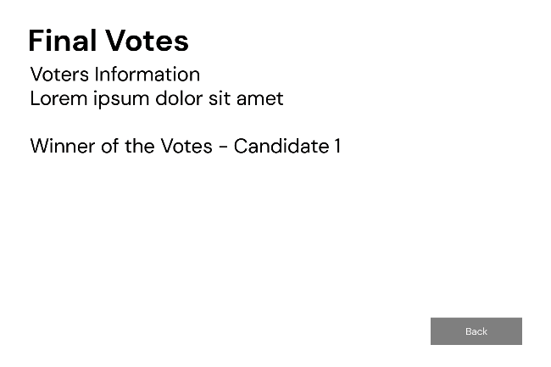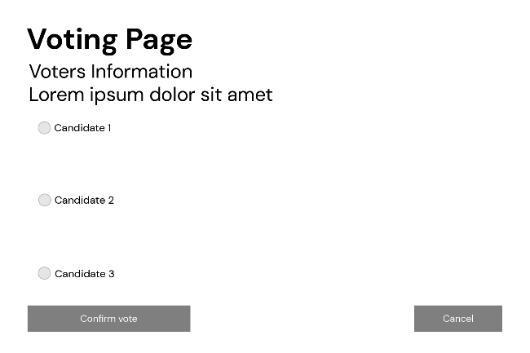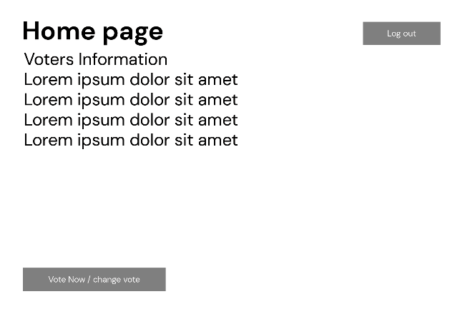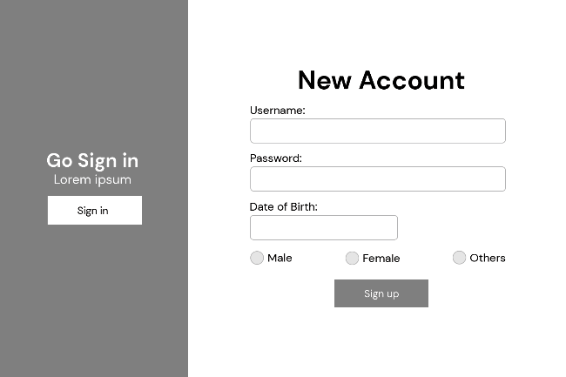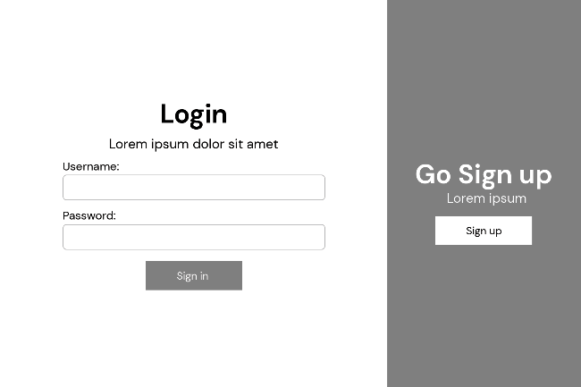SINGAPORE POLYTECHNIC

5. Final votes page

4. Voting page

3. Home page

2. Sign up page

1. Login page

**SCHOOL OF ELECTRICAL & ELECTRONIC ENGINEERING**

### ET0706 Object Oriented Programming---PROJECT CONCEPT PAPER

# 1.5 Object Class Design (can also include Database design) (15%)

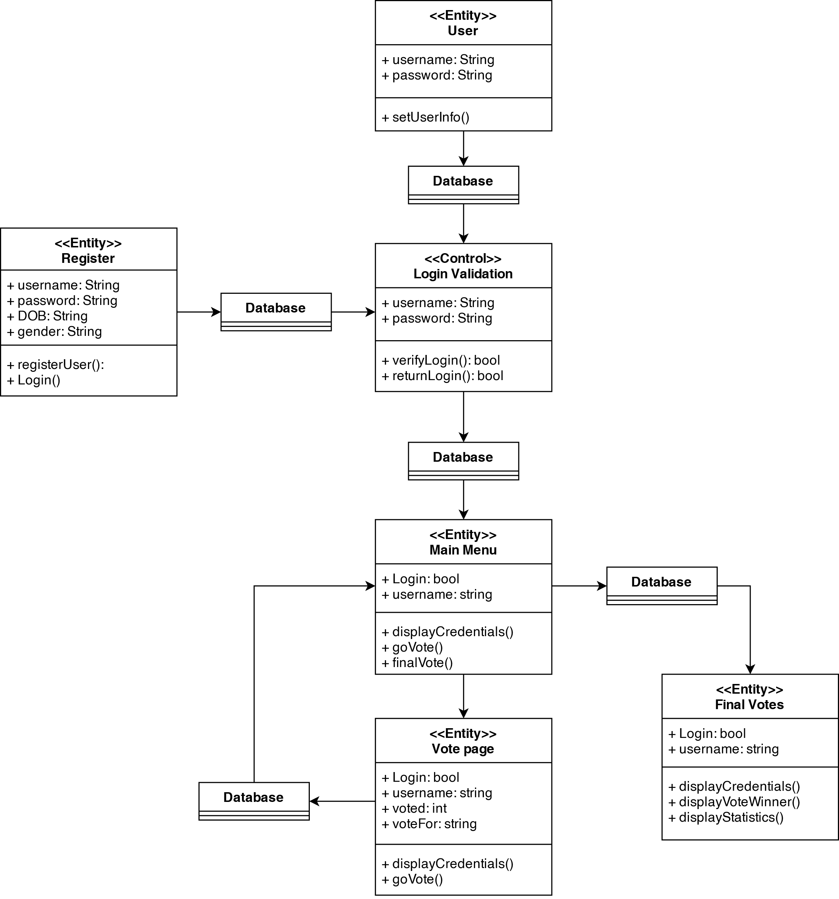 Database Design:

|  |  |
| --- | --- |
| **Column name** | **Variable type** |
| **idvotes** | int AI PK |
| **password** | varchar(45) |
| **names** | varchar(45) |
| **gender** | varchar(45) |
| **voted** | varchar(45) |
| **voteFor** | varchar(45) |
| **DOBYMD** | varchar(45) |

SINGAPORE POLYTECHNIC

**SCHOOL OF ELECTRICAL & ELECTRONIC ENGINEERING**

### ET0706 Object Oriented Programming---PROJECT CONCEPT PAPER

# *2.* Commercial Aspects (10%)

How do you intend to charge/generate revenue from your project?

My intention on generating revenue from this project is by having companies and/or government agencies lease out my application to be used and modified by them or hire me to modify the application as needed.

## 3. Difficulty Faced (10%)

## Briefly describe the areas where you have difficulty and need help in implementing this application in terms of skill set, design, etc.

Java to me is already a foreign language, learning it the first time for this module, not to mention the additional JavaFX plugin that is required to be used. Another setback, that I may encounter is the linking of the database from Java to MySQL.

**4. Resources(10 %)**

List the resources, like useful URL, API documentation, books, etc. you used for generating the concept and intend to refer to / get help from to implement the software design.

e.g. For flowchart:

<http://wiki.utep.edu/download/attachments/27984855/Introduction_to_Flowcharting.doc?version=1>

<http://www.programiz.com/article/flowchart-programming>

<https://www.youtube.com/watch?gl=SG&v=IkZsQN3Dkxc&hl=en-GB>

Your resources:

<https://youtu.be/9XJicRt_FaI>

<https://app.diagrams.net/>

<https://www.office.com/launch/visio?auth=2>